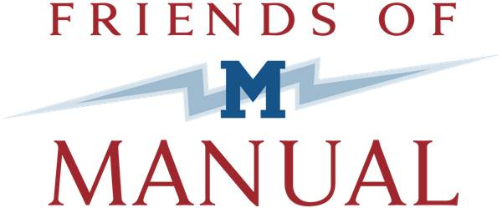

Application for Friends of Manual Board Membership
Thank you for your interest in becoming a Friends of Manual Board Member. Friends of Manual High School (FOM) is a 501(c)(3) nonprofit organization dedicated to supporting the academic achievement and overall high school experience of students at Manual. FOM was started by a group of alumni committed to public education in Denver and with a desire to find ways to connect in a positive way with their Alma Matter.

FOM’s primary role has been to provide support for the educational and financial needs outside the realm of general funding. In addition, FOM has served as community advocates.

To continue our work, we are currently looking for dedicated, quality members to assist the organization in its next phase of development. We are in the process of increasing our board to lead the organization into the future.

If you are interested and can perform the duties below, please fill out the application on the next page:

Major responsibilities:
- Ensure the relevance of the agency vision, mission, values, and purpose.
- Determine policies and oversee procedures.
- Promote, communicate, and advocate the agency mission and programs to the community.
- Fundraise and reach out to the community.
- Provide organizational leadership and advisement.
- Provide financial stewardship, including adoption and oversight of the annual budget.
- Review the organizational, development, and program reports.

Meetings and time commitment:
- The board of directors meets 11 times per year with dates and times set by the Board President.
- Committees of the board meet, pending their respective work agenda.
- Board members are expected to perform various duties outside of meetings

General Board Member Job Description
- Learn the history, policies, and strategies of FOM.
- Financially support FOM including participating in fundraising activities.
- Understand the FOM finances, budget, and financial/resource needs.
- Attend and participate in FOM board meetings, small-group meetings, retreats and the main breakfast
- Promote, communicate, and advocate the agency mission and programs to the community.
- Bring to the board any community concerns that can be addressed by FOMs’ mission, objectives, and programs.
- Volunteer for and willingly accept assignments and complete them thoroughly and on time.
- Participate on a standing committee of the board and/or task forces as necessary.
- Get to know other board members and builds collegial working relationships.
- Maintain appropriate confidentiality concerning FOM business.

Name: ___________________________________________

Home Address: ___________________________________ City: Zip: ___________

Home Phone: Work Phone: Cell Phone: ______________

Email: _________________________ Occupation: ___________________Title: ___________________

Work Address: ___________________________________ City: Zip: ____________

What other boards do you currently serve on (please include names and positions held)?
___________________________________________________________________________________________________________________________________________________________________________________________________________________________________________________________________________

What other boards have you served on (please include names and positions held)?
___________________________________________________________________________________________________________________________________________________________________________________________________________________________________________________________________________

Why are you passionate about FOM or its work?
___________________________________________________________________________________________________________________________________________________________________________________________________________________________________________________________________________

What skills can you provide that will help the organization and the board?
___________________________________________________________________________________________________________________________________________________________________________________________________________________________________________________________________________

How much time (hours per month) do you have to assist FOM if you are selected for the board?
__________________________________________________________________________________________________________________________________________________________________________________

Is there anything else that we should take into consideration when discussing your candidacy?
___________________________________________________________________________________________________________________________________________________________________________________________________________________________________________________________________________

Please email this application to Fom@friendsofmanual.org upon completion

